Exercise 1: Control Structures – Analysis

Scenario 1: Loan Interest Discount
Requirement: Apply a 1% discount to loan interest rates for customers above 60 years old.
Logic Used: Loop through all customers, calculate age from DOB, check if age is greater than 60, and reduce the corresponding loan interest rate by 1%.
Expected Result: Interest rates are updated only for eligible senior customers.
Implementation:
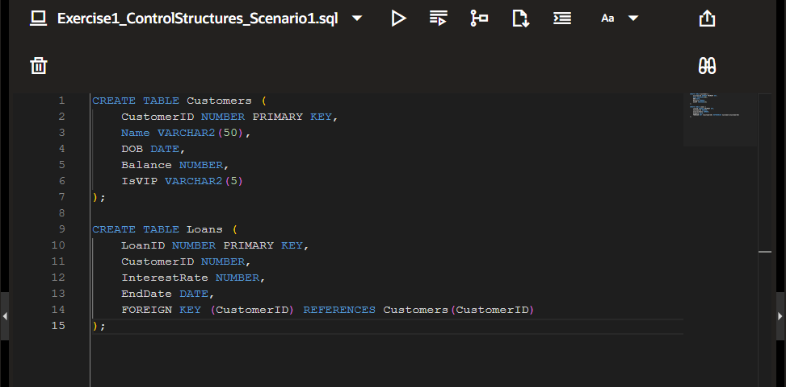
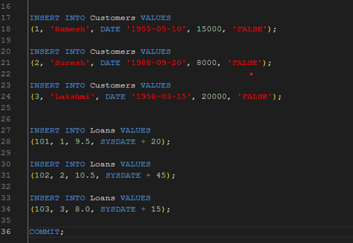
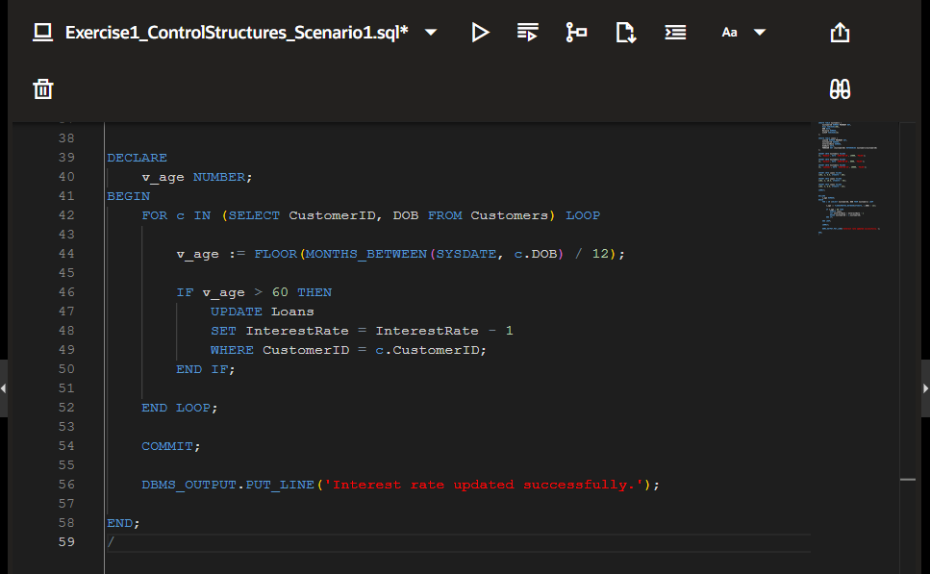

Output:
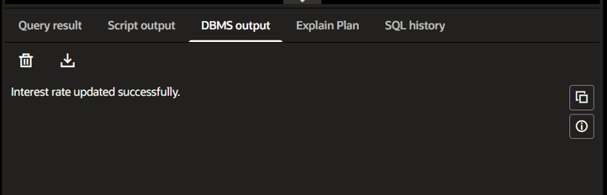
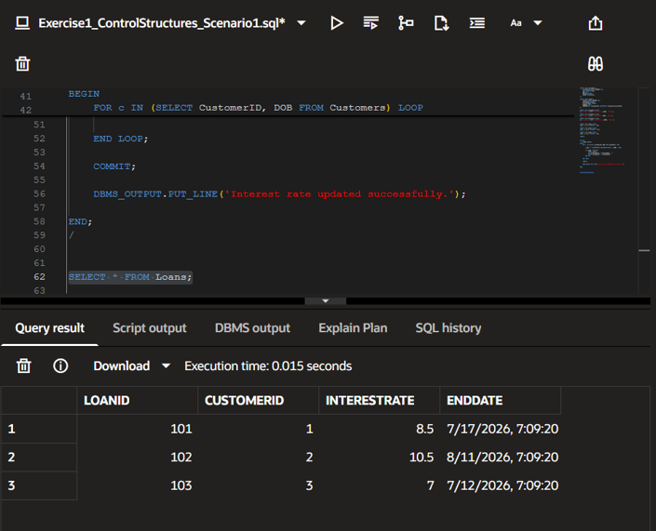

Scenario 2: VIP Customer Promotion
Requirement: Set the IsVIP flag to TRUE for customers with a balance greater than $10,000.
Logic Used: Iterate through the Customers table, check each customer's balance, and update the IsVIP column when the balance exceeds $10,000.
Expected Result: Eligible customers are successfully promoted to VIP status.
Implementation:
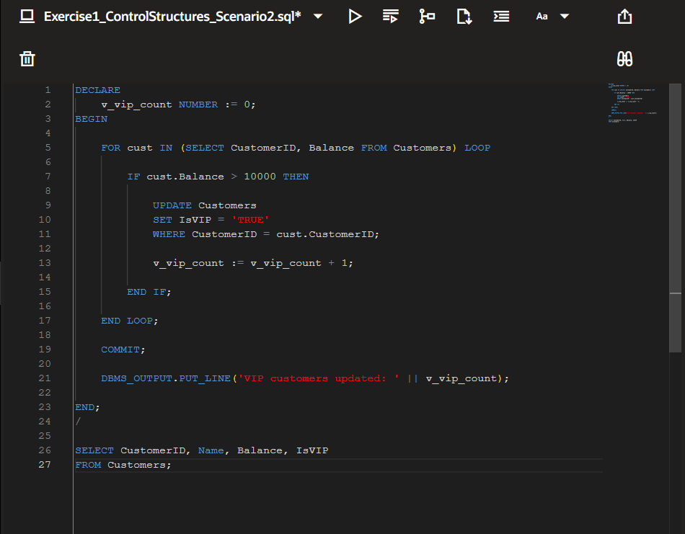

Output:
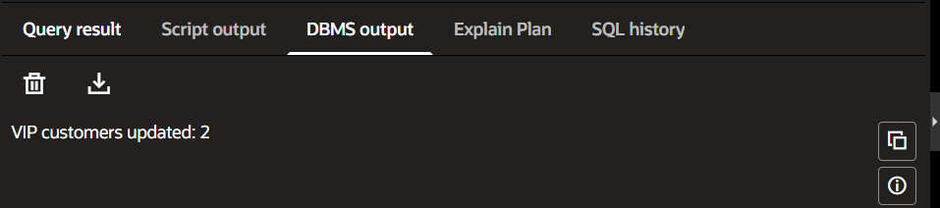
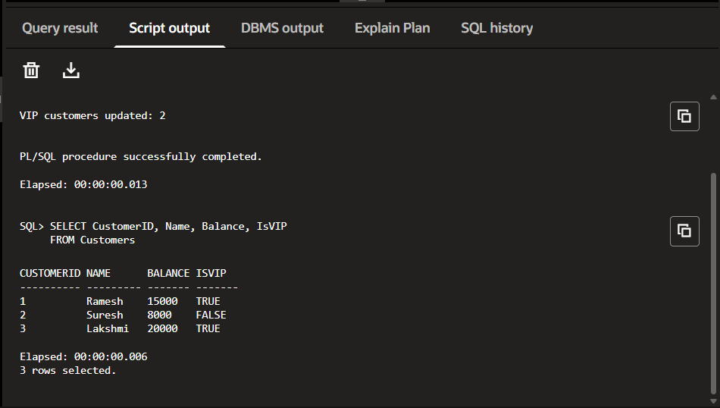
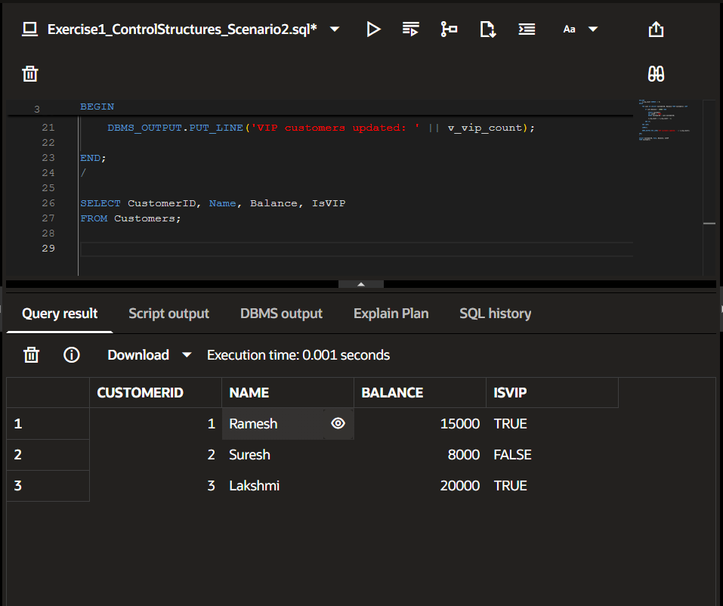
Scenario 3: Loan Due Reminder
Requirement: Print reminders for loans due within the next 30 days.
Logic Used: Join Customers and Loans tables, identify loans due within the next 30 days using SYSDATE, and display reminder messages with DBMS_OUTPUT.PUT_LINE.
Expected Result: Reminder messages are generated only for qualifying loans.
Implementation:
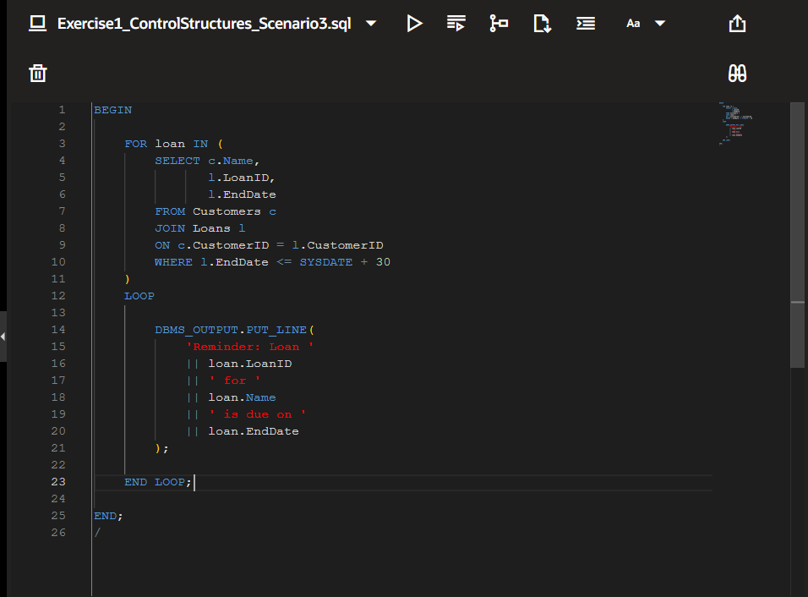
Output:
